Upgrade from Joomla 2.5 to Joomla 3.x is Not So Scary
Paul Frankowski
17 December 2014

The Joomla! Project in December 10 announced availability of Joomla 2.5.28. This is the last release for the 2.5 series of Joomla! and is the final scheduled release of the series. Official support for Joomla! 2.5 is scheduled to end on December 31, 2014.
This means that there are no new releases planned for Joomla 2.5, as the Joomla project is putting all its efforts in its Joomla 3.3 and upcoming 3.4 series.
But don't worry and relax, it doesn't mean that after this date you CMS will be turned off. Your website still be on-line, and still secure as much as it was before.

This CMS series began in January 2011 as Joomla 1.6 and in July 2011, Joomla 1.7 was released. Both of these versions were steps to the long-term release of Joomla 2.5, which came out in January 2012. So yes, it was long two years. In mean time Joomla 3.3 has appear. Joomla 3.3.6 is currently the latest stable release of the powerful and flexible CMS. Do you need to hurry up and upgrade to Joomla 3? Hmm, hard question. It's depends of many elements. But of course we suggest to think intensively about this task in next upcoming months.
Here is short list of preparations before upgrade (mini migration). Please reserve at least 2h for this procces. It's better to finish before this time, than be in hurry. They allows you to be calm and focused on the task:
- Full backup (files & database) - you can use free version of Akeeba Backup component
- Check if your hosting is ready for new CMS version. Requirements for Joomla! 3.x are here: http://www.joomla.org/technical-requirements.html
- In Hosting panel create a new sub-domain, for example j3.domain.com. Create also a new database.
- On this new sub-domain recover whole site from back-up.
- Rewrite to your notes all addcional extensions (modules, components, plugins) which you have there. Then one by one check which version you have and on developer site if there is a new version for J3 only, or this is this same package as you have. Download all new versions.
- Also check your template, but in most cases also "old" template should work after upgrade.
- Then if you're not sure about especially plugins turn them off, because mostly only plugins can "kill" administrator panel.
- Componets -> Joomla! Update -> Options. Here, you will need to switch the Update Server option to Short Term Support then Save changes.
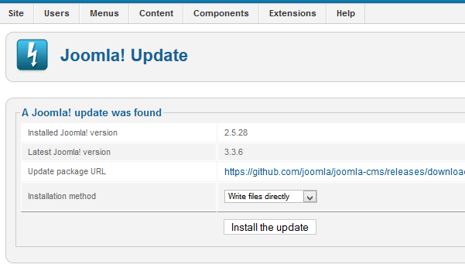
- You should see message about possibility of upgrade with action button. Click upgrade, and in mean time you can make a coffee, tea or mango shake.... it will take few minutes.
- If no errors, you can say "ufff". But I suggest to check database. Navigate to Extension Manager: Database. You will initially have Database problems when you check the Database. Click on the Fix icon to correct the problems. Now the screen should show that the database is up to date.
- Now you have to reinstall all modules and components which have new version for J3 only. It's important to note here that all of your extensions should be Joomla 3.3+ compatible. If they are not, your site could lose functionality or fail to load properly after the update.
- Check if template still working, if not or have errors from template only, reinstall it also.
- Then plugins part - check if those which were turned off after publishing them don't make a blank screen or any other strange issues or error messages.
- And if you're sure that everything is working well. Time to make another full copy and transfer this upgarded version to new location, to "old" domain.

How to fix errors after upgrade J25->3.4+
Tip #1: Sometimes even after successful upgrade from 2.5 -> 3.x and migration from localhost or sub-domain into domain you will not be able to login into admin. You will see blank (white) screen or error message. It might be caused by "old" foler: libraries/cms/controller. In Joomla 3.3+ he is not necessary, it should have been removed since J3.0 ! Please do it via FTP, then clean cache and probably you will be able to login into J!3 administration dashboard.
Tip #2: I think it's good idea after migration from server A to B to reinstall Joomla 3.3+ again. It can fix some problems which were hidden after update addcional extensions. This is very simple part, just install Joomla patch package using Extension Manager, for example use this file: Joomla_3.3.x_to_3.3.6-Stable-Patch_Package.zip (download from Joomla.org). It will take you less than 3 minutes but can solve many problems with database structure.
Tip #3: Most problems on front-end after upgrade from old Joomla into new one are caused by old, incompatible or poorly written plugins. I suggest to set showing errors in Global Configuration into maximum - to see which one generates error messages and crash layout. In most cases you can disable them, then uninstall and find replacement which will work with Joomla 3.x without ay problems.If you are not php developer this is the only way. Of course you can always try to ask t developer about "quick" update.
Tip #4: For not yet blocked Joomla 2.5 at the error page during update the easiest solution would be to disable the "System - Remember Me" Plug-in before running the update and re-enable it just afterwards. In some cases JoomlaUpdate may fails if remember me plugin is enabled,

Others resources about Joomla migration
Please also read those articles about Joomla 2.5 -> Joomla 3.x migration problems / issues:
- https://docs.joomla.org/Joomla_2.5_to_3.x_Step_by_Step_Migration
- https://docs.joomla.org/Planning_for_Mini-Migration_-_Joomla_2.5_to_3.x
- https://docs.joomla.org/Joomla_2.5_to_3.x_Common_Migration_Errors
- https://docs.joomla.org/J3.x:Table_xxx_postinstall_cpanels_does_not_exist

Joomla 2.5 to 3.x Step by Step Migration

De Joomla! Documentation

Outros idiomas:
български • ‎català • ‎dansk • ‎Deutsch • ‎English • ‎español • ‎français • ‎Nederlands • ‎português do Brasil • ‎русский • ‎Türkçe • ‎中文（台灣）‎
The following are step by step instructions to migrate your 2.5.x site to Joomla! 3.x. While there are hundreds of different scenarios, this will give you the basic procedure to follow. Very complex migrations will likely be a result of installed third-party extensions. You are encouraged to contact the developers of third-party extensions installed on your Joomla! site for their suggested path to migrate their extensions.

Índice
- 1 Intro
  - 1.1 For very large or complex 2.5 to 3.x migrations
- 2 Step by Step
  - 2.1 Set up a Development Location
  - 2.2 Assess Each Extension
  - 2.3 Going to Joomla! 3.x
  - 2.4 Going Live with your Joomla! 3.x Site
- 3 Suggested Tools

Intro
The migration from Joomla! 2.5 to 3.x is considered a mini-migration. This is because the Joomla! core extensions will upgrade with a “one-click” upgrade via the Joomla! Update component in the backend administrator side of Joomla. Many third-party extensions are a one-click upgrade too. Some are not. You need to look at each one and determine what path the extension needs to follow to get from 2.5 to 3.x. If you haven't already, you might be interested in reading the Self Assessment and Planning for 2.5 to 3.x Migration prior to following the steps below.
Joomla! Core Extensions:
- Categories
- Articles
- Menus
- Modules (core modules - not third-party)
- Banners
- Contacts
- Messaging
- Newsfeeds
- Redirect
- Search
- Smart Search
- Weblinks

For very large or complex 2.5 to 3.x migrations
The one-click update will be fine and work well for many. For some larger, more complex sites, the one-click update may not be the best route. For large or very complex sites, you may want to follow instructions for a regular migration and bypass the one-click update functionality. To do this, follow the same instructions for planning 1.5 to 3.x and migrating from Joomla 1.5 to 3.x, simply substitute 2.5 for 1.5 while reading.

Step by Step

Set up a Development Location
- Take a backup of your live 2.5 site. You can use a suggested tool (see bottom of page) or you can do this manually.
  - Backup Basics for a Joomla! Web Site
  - What are the best practices for site backups?
- Make sure your environment meets the technical requirements for Joomla 3 before proceeding.
- Create a new database and new user to restore your 2.5 site to.
- Create a testing site or build area to work in and restore the back up copy of your 2.5 site in one of the following places:
  - A subdomain.
  - A subdirectory.
  - A local device via WAMP, MAMP, LAMP, XAMPP.
  - A new hosting account on a temporary domain in the root. (If you would like to change hosts in the process of migration).
    - Restoring a site on a local device. See Installing Joomla locally and Setting up your workstation for Joomla development.
    - Restoring a site with a tool listed at bottom of page. (Read the developer documentation)
- In your test location, update your Joomla! 2.5 instance to the latest maintenance release. (Currently 2.5.28).
- Make sure you have the latest database schema updated to the latest version 2.5.28 by going to: Extension Manager → Database tab. If your schema is not up to date as in the following image, click the Fix button:
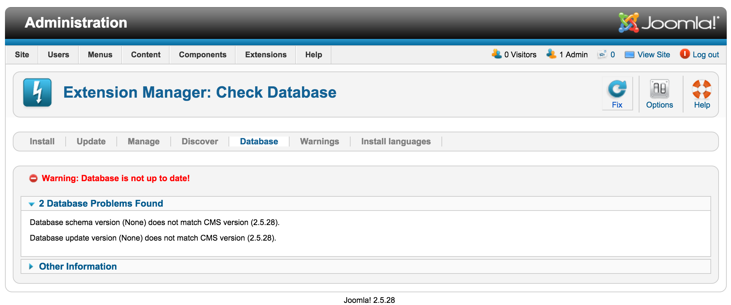
- Test.
- Backup again.

Assess Each Extension
- You are going to be looking at every single extension installed on your site. You will be determining if they need to be updated to the latest version or uninstalled. In Joomla! 2.5.28 you can go to Extension Manager → Update tab and click Find Updates which will add a tooltip in the Version column, under the Manage tab, giving some compatibility information from the backend. This functionality only supports extensions that update via the Extension Manager Update tab. If you have extensions installed that do not use the Joomla extension update then they need to be assessed manually as detailed below. The same goes for those extensions that have a tooltip. You will still need to check the type of package and migration path with the extension developer to verify how to upgrade/migrate.
- Go to Extension Manager → Manage tab
- Click the drop-down for Type.
- Select Package from the drop-down.
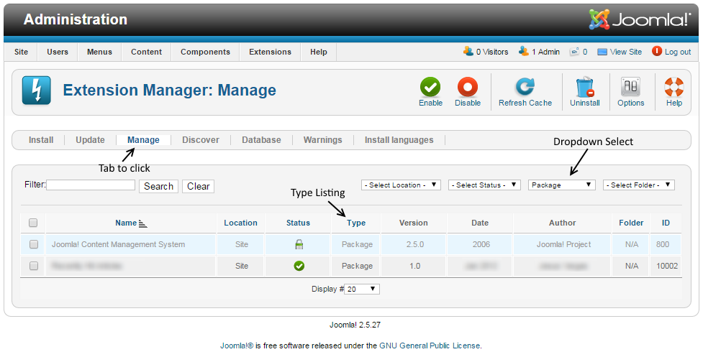
Selecting Package first is recommended because if there is something you need to uninstall in a package, it will automatically uninstall the associated Modules, Plugins, or anything else in the package at one time.
- Uninstall any Packages that are no longer needed or will not be migrating to Joomla 3.
- Repeat this process of going through the Manage tab for all Types in the drop-down: Component, File, Language, Library, Module, Plugin and Template. If the Author states Joomla! Project, then leave those extensions alone. Smart Search is a Joomla core supported extension even though the Author fields are blank. For all others, make sure that you uninstall those not in use or not compatible with Joomla! 3.x.
NOTE! You will not be able to uninstall any Template that is set as default. You will need to select a Core supported template like Beez or Atomic and then uninstall the template if you need to do so.
- Make a note of any versions of Packages and Components currently running that you will be keeping on your site. You can use the Third-Party Extension Inventory Worksheet or just copy/paste them into a document for reference.
- Update all extensions to the latest versions.
- Before and as you update, note if the extensions have both 2.5 & 3.x versions in the same package. If so, they will be fine to "one-click update." If not, and 2.5 and 3.x have different packages, you need to look at them case by case. They will normally fall into one of the following scenarios:
  - The extension has separate packages but upon upgrading to 3.x, they automatically detect this and still work. Make sure the developer confirms this.
  - The extension has separate packages that need to be uninstalled in 2.5 and then installed with the Joomla 3.x version once the site is migrated. An example of this might be a content plugin. It is very simple to uninstall it in 2.5 and then install it again in 3.x.
  - See Template Considerations for more specific information on templates.
Note on Core Supported Extensions: If you are using a Core Supported Extension (Banners, Contacts, Messaging, Newsfeeds, Redirect, Search, Smart Search, or Weblinks) in Joomla! 2.5 and it has been decoupled in Joomla! 3.4+, Joomla will detect their use during the upgrade and install those Core Supported Extensions automatically.

Going to Joomla! 3.x
Once you have either updated or uninstalled your third-party extensions so that only those compatible with Joomla! 3 remain in your installation, continue with the following steps:
- Go to Site → Global Configuration → Server tab and turn Error Reporting from System Default to Maximum. Make sure to Save & Close.
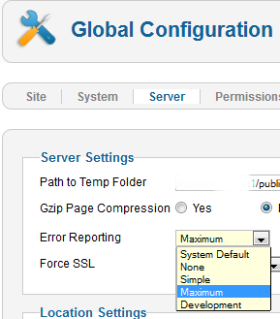
- Go to Extensions → Plugin Manager and enter Remember Me into the Filter and press enter.
- Disable the Remember Me plugin by clicking the green check mark and making it a red circle.
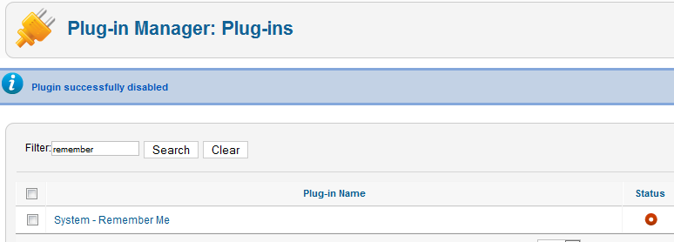
- Take another backup.
- Recommended but not required: Fix assets. (Fixing the assets table). See below for a tool to do this in just a few clicks.
- Go to Components → Joomla Update. (It should say no updates found. If it doesn’t, update Joomla to the latest version and test. Then do another backup.) Click on the Options button at the top right corner.
- Select Short Term Support (This is the current text - it may be different in the future) from the drop-down for Update server.
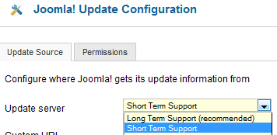
- Click Save & Close.
- You will then see your Installed Joomla Version, the Latest Joomla! version and the URL for the update package.
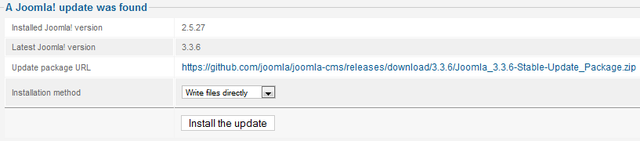
- If the update is not showing up, go to Extension manager → Update and press Purge Cache from the toolbar. Now the update to Joomla! 3 should show up.
- Cross your fingers, make sure you turned off Remember Me and that you have a backup from just before this point.
- Click the Install the Update button.
- Watch the spinning circle go round and round and feel the anxiety building. No, just kidding. The amount of time the wheel spins is dependent on your site, Internet connection and server speed.
- If all goes well, you will get to a totally new look to the backend administrator panel.
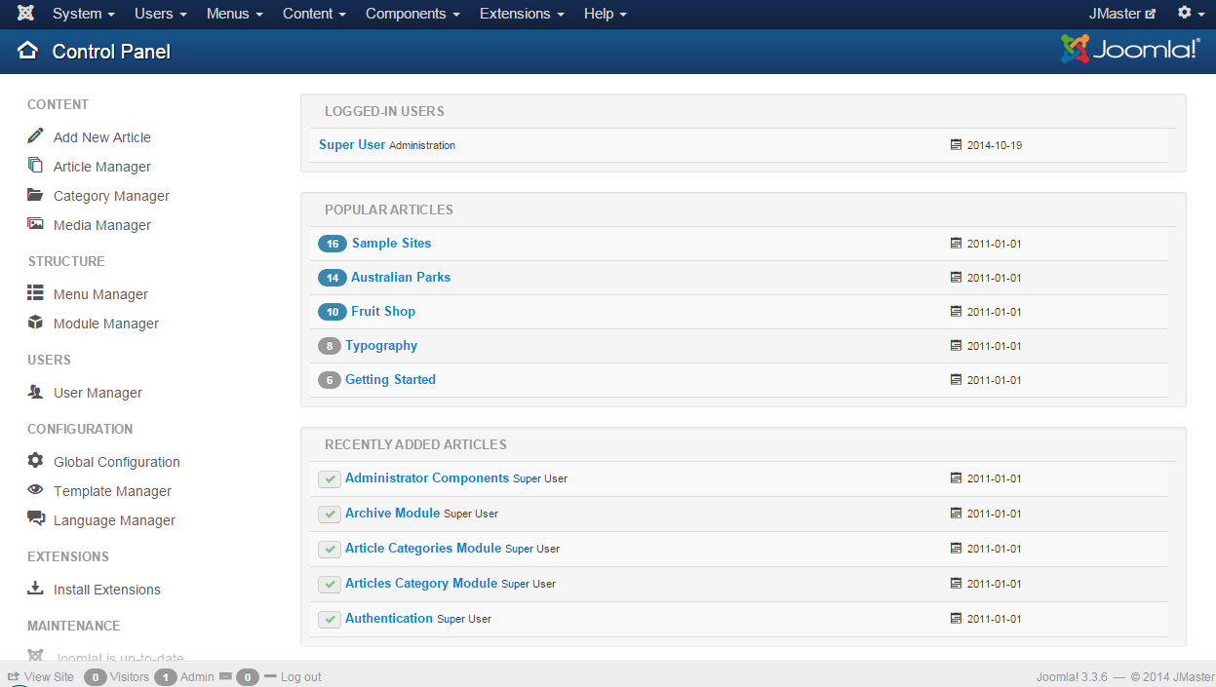
- Click the Clear Cache button.
- Go to Extensions → Manage → Database and click Fix.
- In the Extension Manager, go to Discover and see if there are any extensions to install.
- Recommended but not required: Fix assets. (Fixing the assets table). See below for a tool to do this in just a few clicks.
- Enable Remember Me from the Plugin Manager.
- Go to the frontend of your site and see if it shows up even if it’s not the right template. If so, continue. If not, see common errors during migration.
- Take a backup.
- At this point, it would be prudent to clear your browser's cache. Some browsers, notably Firefox, will retain old version 2.5 files. That caching might prevent the operation of the Save and Save & Close buttons in the Administrator.
- Go to Content → Article Manager → Options button → Editing Layout tab and set the Enable Versions to Yes.
- Install your new template or other extensions if you have them to install. Back up often.
- Configure them. Back up often.
- Test everything. Back up often.
- If everything works as expected, turn Error Reporting back to System Default (System → Global Configuration → Server tab). Make sure to Save & Close.

Going Live with your Joomla! 3.x Site
- When you’re ready to go live, back up your 2.5 site for the last time. Restore it in a subdirectory or subdomain if you would like to.
- Back up your Joomla! 3.x site and move or restore your Joomla! 3.x site to the root (or change nameservers if you were building on a temporary domain at a new hosting account root).
- Test again.
- Remove the Joomla! 2.5 site from the server within a couple of days unless you have edited your robots.txt file to block the search engine spiders.
- Remove all development sites you may have been working with or keep them up-to-date if they are running a current version in order to ward off hack attempts on your server.
If you had data change on the 2.5 site while you were migrating to 3.x, you will want to get that data moved over to the 3.x site before going live. You can do this manually (make sure you keep the same user IDs - go in order) or by using a transfer tool/third-party extension.

Planning for Mini-Migration - Joomla 2.5 to 3.x

De Joomla! Documentation

Outros idiomas:
български • ‎català • ‎Deutsch • ‎English • ‎español • ‎français • ‎Nederlands • ‎português do Brasil • ‎русский
Going from Joomla 2.5 to 3.x is considered a mini-migration or a minor migration. This means that Joomla core extensions will upgrade with a “one-click update” but third-party extensions are debatable and need to be taken on a case by case basis.
The one-click update will be fine and work well for many. For some larger, more complex sites, the one-click update may not be the best route. For large or very complex sites, you may want to follow instructions for a regular migration and bypass the one-click update functionality. To do this, follow the same instructions for planning 1.5 to 3.x and migrating from Joomla 1.5 to 3.x, simply substitute 2.5 for 1.5 while reading.

Intro
Migrations are a great time to reassess goals, clean up, and develop other areas/elements of your site. The more organized you can be with your ideas/thoughts/plans the better. Plan, plan, plan. Planning makes execution easier.
Start planning by asking the following questions or doing the tasks listed below. You may have more items to plan for depending on the complexity of your site. Sadly, there is no way we can list every possible scenario. You can ask specific questions on the Joomla 3.x Migration Forum.

Planning Action Items
- Assess your original site goals. Migration is an opportunity to get back into focus with your goals or change direction.
- Does your server meet the minimum technical requirements for Joomla 3? If not, you will need to change hosts. No better time to change hosts then during a migration.
- What kind of development environment will you use? A development environment on your local device? A subdomain or subdirectory on your server? A new server/hosting account due to technical specifications?
- Make a list of all third-party extensions in use. This includes components, modules, plugins, languages, and templates. You may use the Third-Party Extension Inventory Worksheet or just copy/paste them into a document for reference, or a paper and pen works too. Include if these extensions are used heavily, moderately, hardly ever, or not at all.
- Determine whether the third-party extensions you rely on are ready for the version of Joomla you are migrating to.
- Determine if you really need all the extensions you are using. Could it be that Joomla 3 has built in features that could eliminate the use of a third-party extension?
- Take a look at your Categories and Articles. Is there clean-up that needs to be done so that you don’t migrate unnecessary content?
- What about your template? If you purchased your template from a third-party source, is there a 3.x version released for it? Would you like to continue using it? Is there an upgrade path published by the developer? Is the new version of it responsive? Is your template a custom template? Or was it heavily customized from a third-party template? For an expansion of Template based considerations, see Template Considerations During Migration.
- If you are changing out your template for a new one, will it require any new images? For example, if your current site has a white background and your logo or other images are .jpg images with a white background it won’t look very nice against a new template with an off-white or coloured background.
- If you redesign or make changes to your site design or navigation, will you have obsolete pages that will require a redirect?

